* //Grab the response

def response=messageExchange.response.responseContent

It will grab the response of the request under which this script assertion is written.

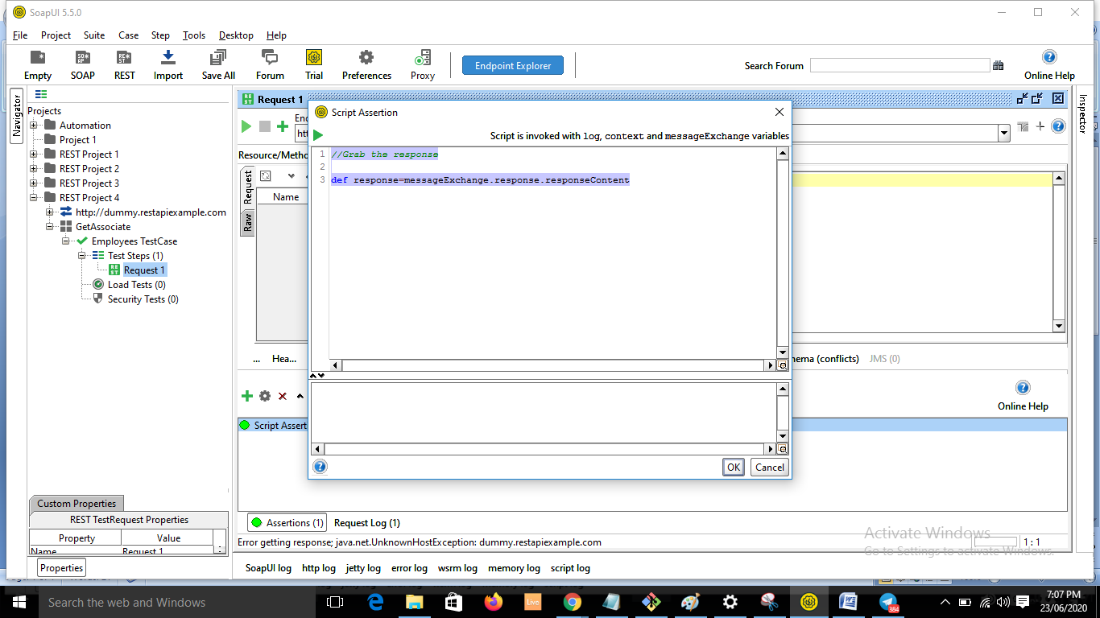

* //Scripting Assertions -- Json and xml

xml - xmlholder

Json – JsonSlurper

* Import this:

import groovy.json.JsonSlurper

* Parse the json now:

def response=messageExchange.response.responseContent

def jsonsl=new JsonSlurper().parseText(response)

* To print value

log. info jsonsl.data[4].id

